Case Study:

1. Establish a project Charter for Jeff based on the assignment given to him by Grace Monroe.

**Project Charter**

Project Name: **Proposal Creation Process Optimization**

Problem Statement:

Gentech faces extended cycle times and inefficiencies in its sales proposal creation process, hindering its competitiveness and resulting in an 18% reduction in revenue in the last 2 years due to

Objective and Scope:

The objective of this project is to streamline the proposal creation process, reduce cycle time by 15%, eliminate non-standard practices, standardize the process, reduce unnecessary approvals, eliminate inefficiencies, streamline the process, combine redundant tasks, and enhance the experience and expertise of Bid Support Staff. The scope of the project includes the following areas of the proposal creation process: Brand approvals, Product pricing, Seller information completeness, and Bid Support Staff experience and expertise.

Target/Goal Statement:

Gentech aims to reduce average proposal creation cycle time by 15% across all geographies, aligning with the CEO's strategy for improved supply chain efficiency and increased market share.

Project Team and Sponsor:

- Project Sponsor: Grace Monroe, VP of Supply Chain Operations

- Project Manager: Jeff Hugh, LSS Black Belt

- Project Team: Bid Support Specialist, Seller, Proposal Support Manager, Brand Manager, Pricing Team

Customers/stakeholders:

- Sellers

- Bid Support Staff

- Brand Managers

- Customers

CTQs (Critical to Quality):

- Cycle time

- Proposal accuracy

- Seller satisfaction

- Bid Support Staff satisfaction

Operational Metric:

-Proposal cycle time

Performance Benchmarks:

- Target proposal cycle time< 35 days

Resources Needed:

- Proposal support manager

- Bid Support Specialist

- Seller

- Access to ERP system data

Benefits of Implementing the Project:

- Reduced proposal cycle time

- Standardized and efficient processes

- Enhanced expertise of Bid Support Staff

- Improved customer satisfaction

- Increased competitiveness and revenue opportunities.

Swim Lane Chart:

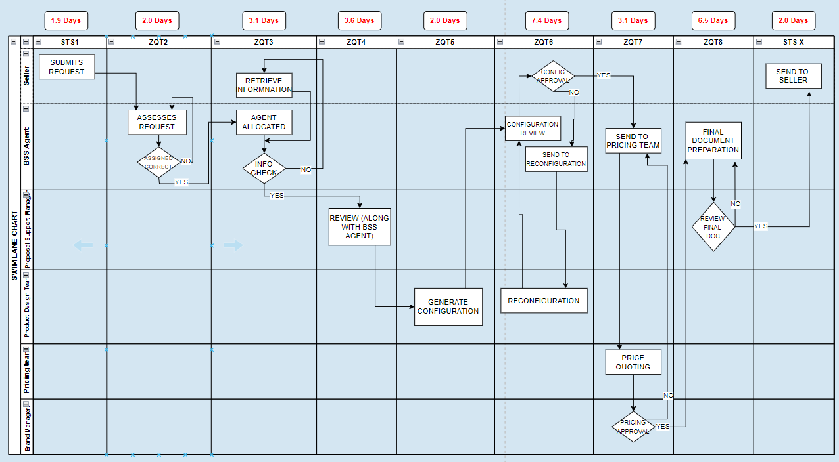

| Timestamp | Avg time |
| --- | --- |
| **STS1** | 1.9 |
| **ZQT2** | 2.0 |
| **ZQT3** | 3.1 |
| **ZQT4** | 3.6 |
| **ZQT5** | 2.0 |
| **ZQT6** | 7.4 |
| **ZQT7** | 3.1 |
| **ZQT8** | 6.5 |
| **STSX** | 2.0 |
| **end-to-end cycle time** | 31.6 |

No.of transactions that takes longer than 35 days = 21079

Total no of transactions = 75000

Dpmo= 281053

Process sigma level = 0.579+off-centering

Generally, off-centering is taken as 1.5

So, Process sigma level = 2.079

Average cycle-time of each geography

Plot 1: Average cycle times by Region

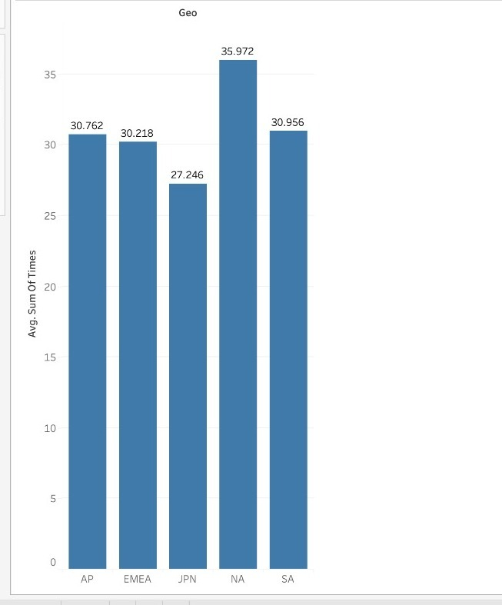

Plot 2: Box plot by Region

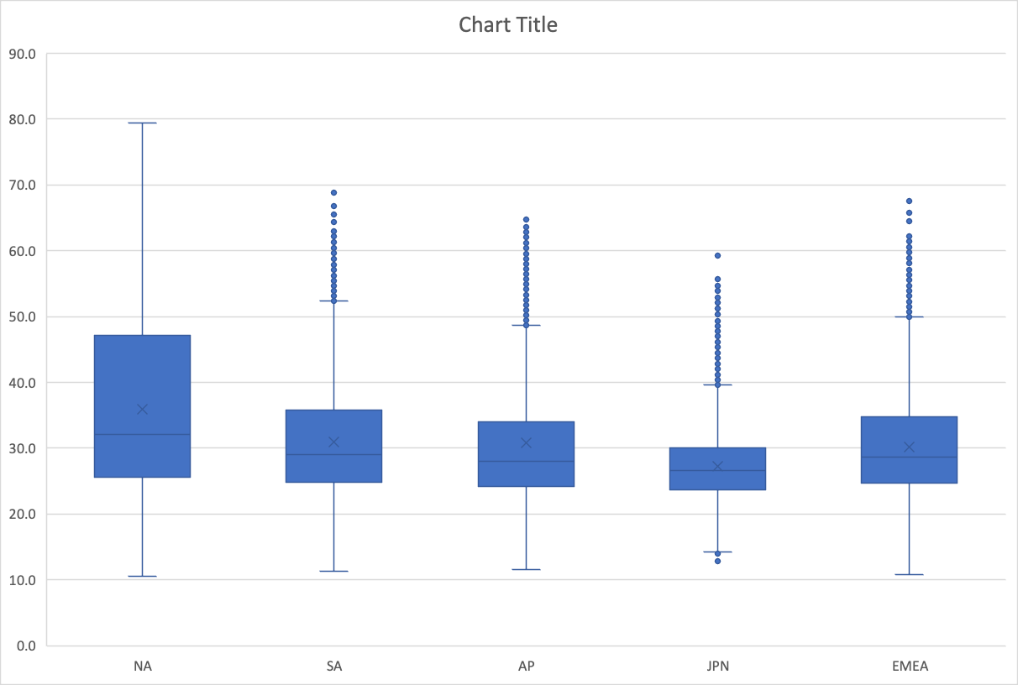

Referring to plots above plots we can observe that North America has the highest cycle time while Japan clocks the lowest. This implies the need for optimization in NA and what other regions can implement by following the process in Japan.

Plot 3: Averages cycle-time of each brand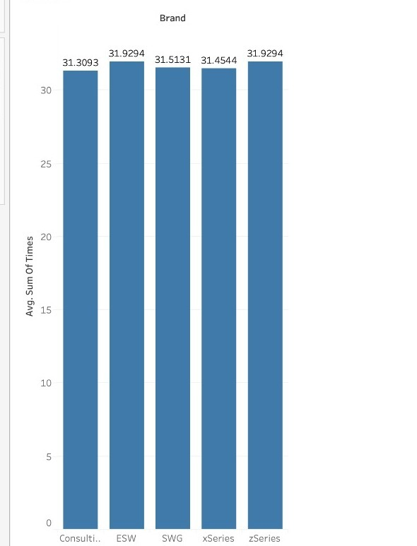

we can see that cycle times when observed across the brands have no significant difference between them, hence to optimize cycle times looking across brands is not recommended.

**Linear Correlation Insights:**

1. High Correlation between Activities: The highest correlations are between ZQT3-ZQT4 (0.766), ZQT3-ZQT7 (0.748), and ZQT4-ZQT7 (0.761). These strong positive correlations suggest that these activities are closely related. When one of these timestamps increases, the others are likely to increase as well, which means these activities might be parts of the process that are closely interconnected, possibly sequentially.
2. Implications for Process Optimization: If you are trying to reduce total time, focusing on the activities with high correlation (ZQT3, ZQT4, ZQT7) may yield better results, as improving one might have positive effects on the others. Since they are strongly correlated, they may share common factors that could be streamlined.

**Covariance Insights:**

The covariance values for the pairs (ZQT3-ZQT4, ZQT3-ZQT7, ZQT4-ZQT7) are particularly high, reinforcing the notion that these activities vary together in a significant manner.

Plot 4: Average cycle-time of each timestamp

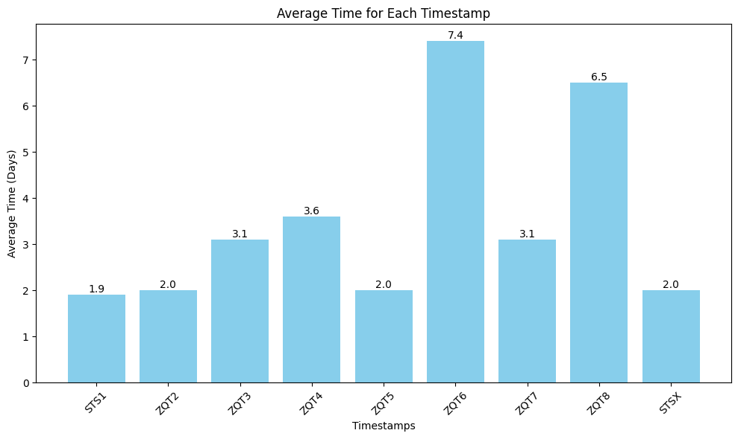

Inference:

1. ZQT6(Configuration approval by the BSS) and ZQT8(Submission of the final document to the PSM) from the above plot take the highest average cycle times implying scope for further optimization in these parts of the processes.

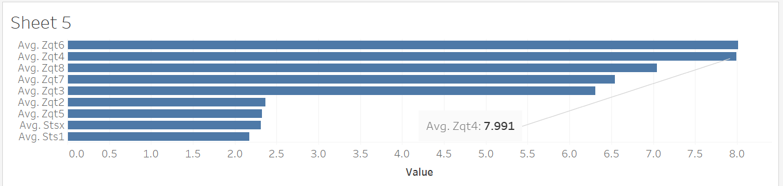

1. While comparing the timestamp cycles for the defective proposals, the value of ZQT4() increases considerably which could be one of the reasons that is causing the defects

Plot 5: Average cycle times of each location wrt each time-stamp

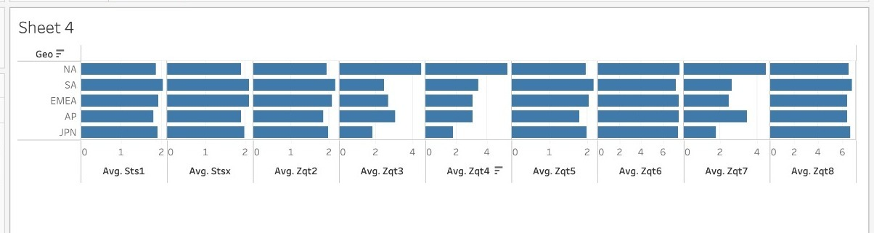

Inference: In our initial inference for cycle times, we observed that NA carried the highest process time. This is majorly due to the cycle times observed in ZQT3, ZQT4, and ZQT7 which differentiates NA from the other regions.

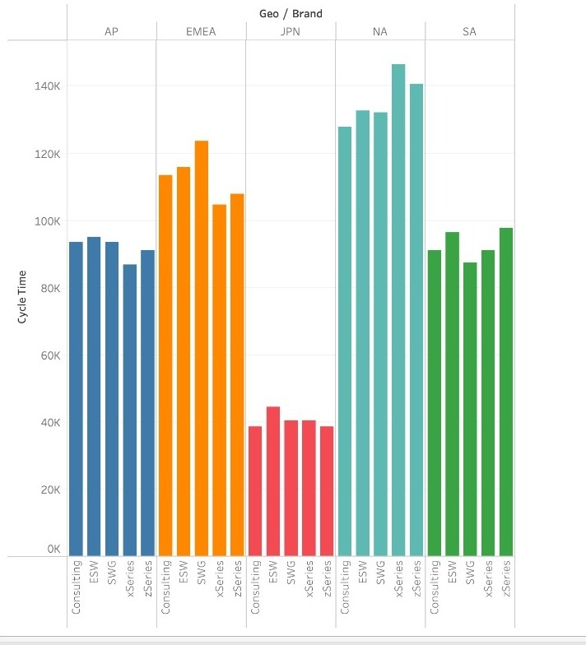

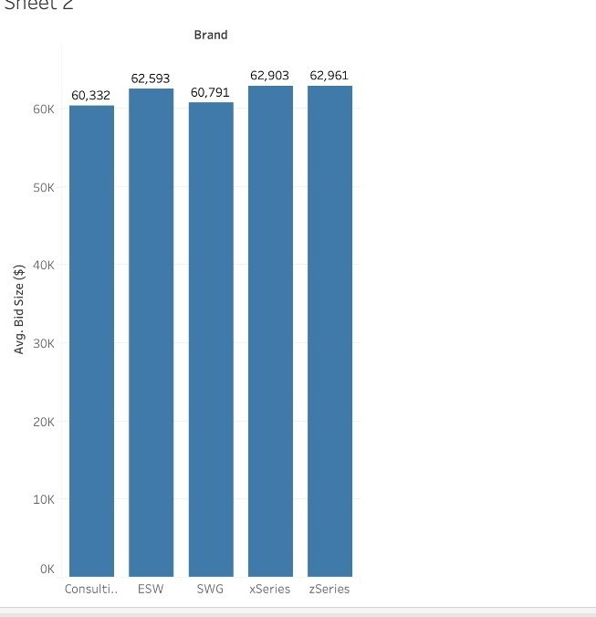

Seller Feedback with Avg timestamp values for each brand

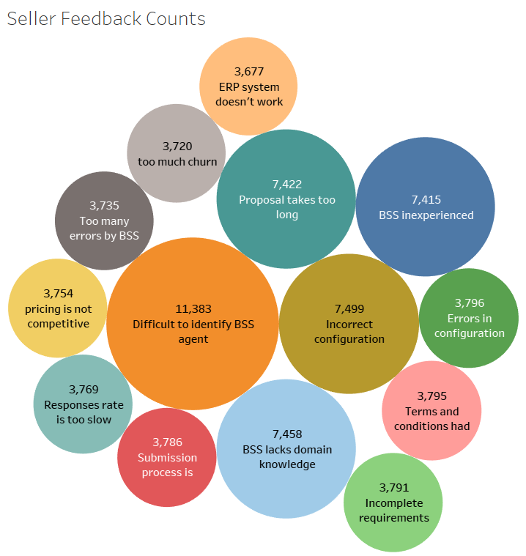

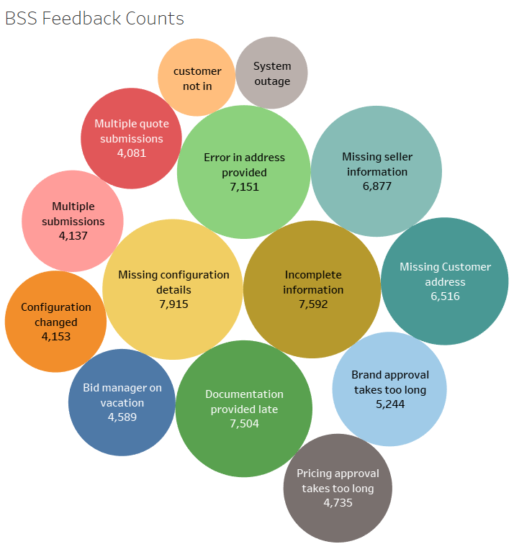

Close to 80% of the issues from the seller feedback include difficult to identify BSS agent, incorrect configuration, proposal takes too long, BSS lacks domain knowledge, and BSS inexperienced. These issues seem to be related in that the BSS agent is not able to configure the bid due to its complexity and has to pass it on to another more experienced BSS Agents with specific roles.

BSS Seller Feedback also has a similar outlook with 80% of the feedback relating to Error in address provided, incomplete information, missing configuration details, missing customer address, missing seller information. All of these issues could be solved with the introduction of a form that had required fields that the seller must complete before submitting the request to a BSS. Additionally, there would need to be a verifiable address in the address field.

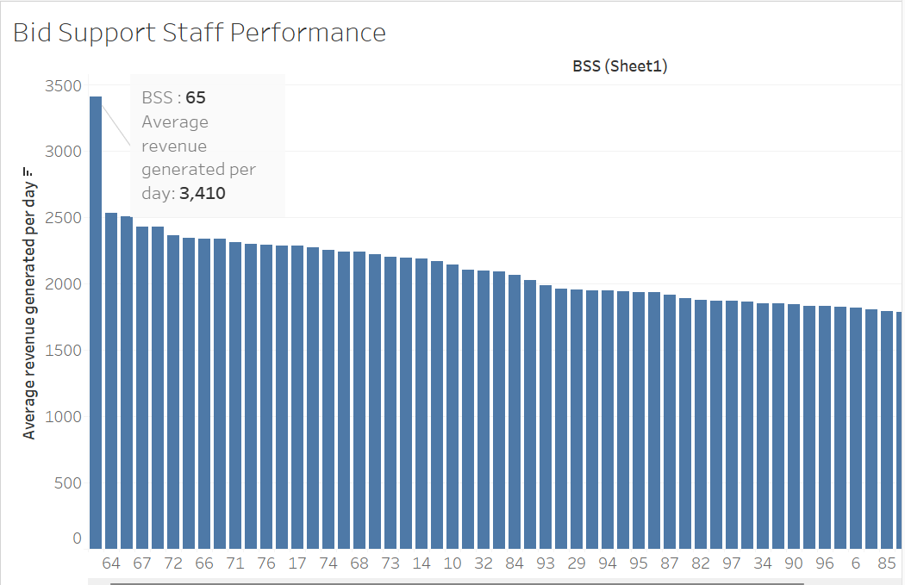

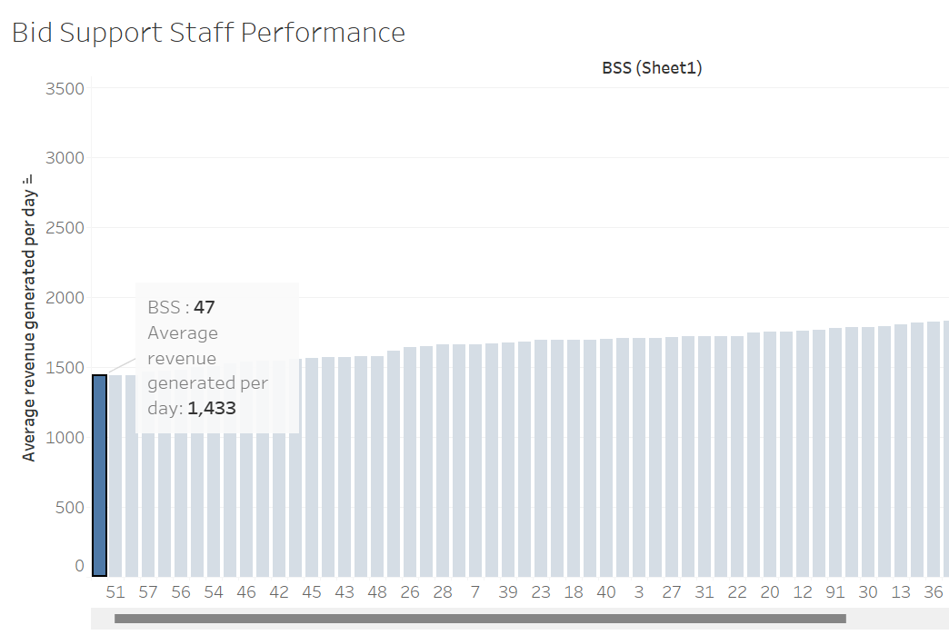

BSS 65 generates the highest revenue per day while BSS 47 generates the lowest.

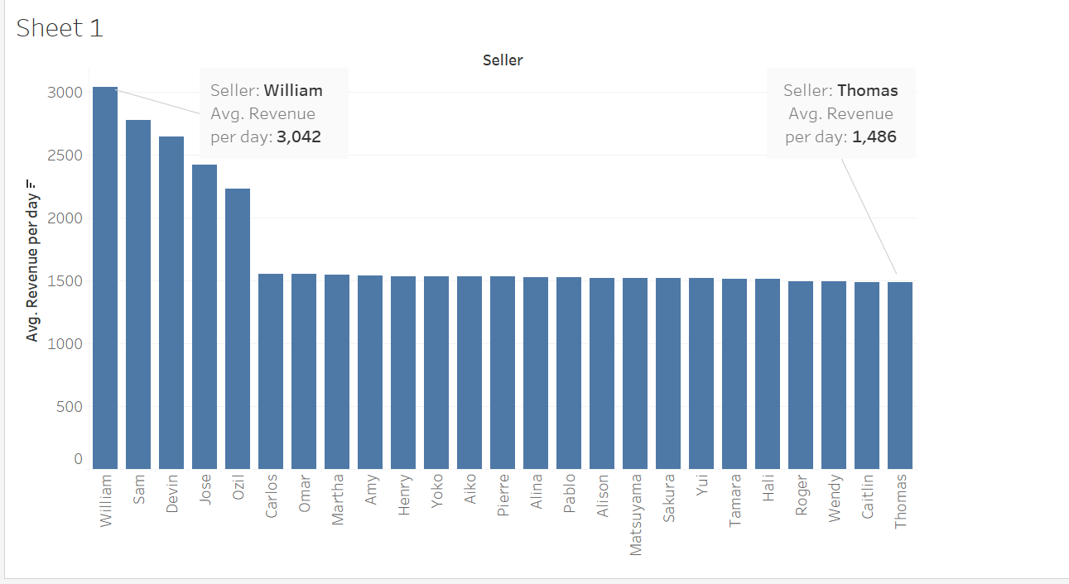

Seller William generates the highest revenue per day and Thomas generates the lowest.

BSS performance based on other parameters:

Calculated average time taken in days to close the bid, average revenue per day and percent of bids resulting in defects(total bids resulting in a defect for a BSS/total bids received by a BSS) and got this table.

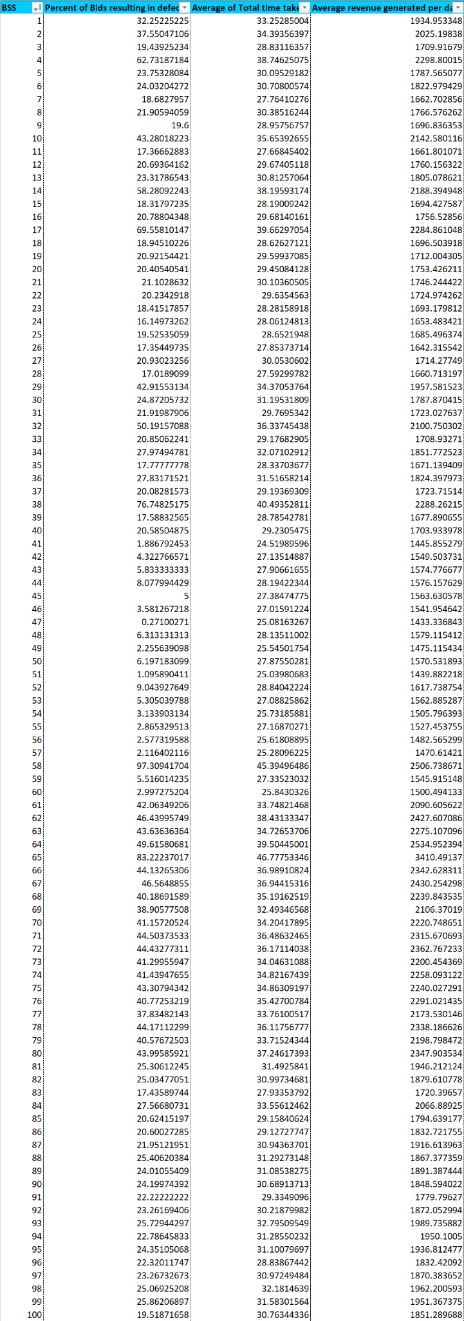

Here the top performing BSS are **71,78 and 72** because they are generating **high revenue while having low cycle time and low percentage of defects in bids.** Also, I calculated the basic statistics of the three fields and found that **87** has above average revenue and below average cycle times and defect rate.  
  
Similarly, the worst performing BSS are **4, 14, 17, 34, 36 and 38** based on the above combined logic.

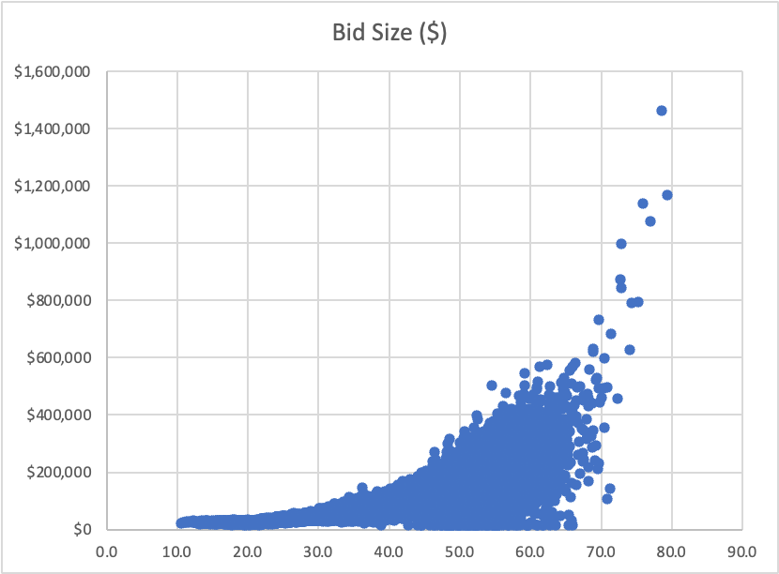

**9.** **Value Added:**

* Seller Identifying Sales Opportunity
* Seller Taking Proposal to the Client

**Non-Value Added but Needed:**

* Product Design Team Creating Configuration
* Configuration Approval by Seller
* Brand Manager Approving Pricing
* BSS Reviewing Request with Proposal Support Manager

**Non-Value Added and Not Needed:**

* Configuration Review by BSS
* BSS Preparing Final Document
* BSS Collecting Missing Information
* BSS Routing to Correct Agent
* BSS Checking for Required Information

Failure modes:

| **Failure mode:** | **Severity** | **Occurrence** | **Detection** | **RPN** |
| --- | --- | --- | --- | --- |
| Inexperienced BSS | 4 | 7 | 5 | 140 |
| Delayed routing to correct agent | 4 | 8 | 5 | 160 |
| missing information | 7 | 7 | 1 | 49 |
| errors in configuration | 5 | 6 | 6 | 180 |
| submission errors | 5 | 2 | 2 | 20 |
| slow response rate | 3 | 4 | 3 | 36 |
| Incomplete requirements | 5 | 7 | 1 | 35 |
| Long approval time | 7 | 3 | 3 | 63 |
| Errors in system | 6 | 2 | 9 | 108 |

Potential Causes and Issues:

Issue: longer cycle time

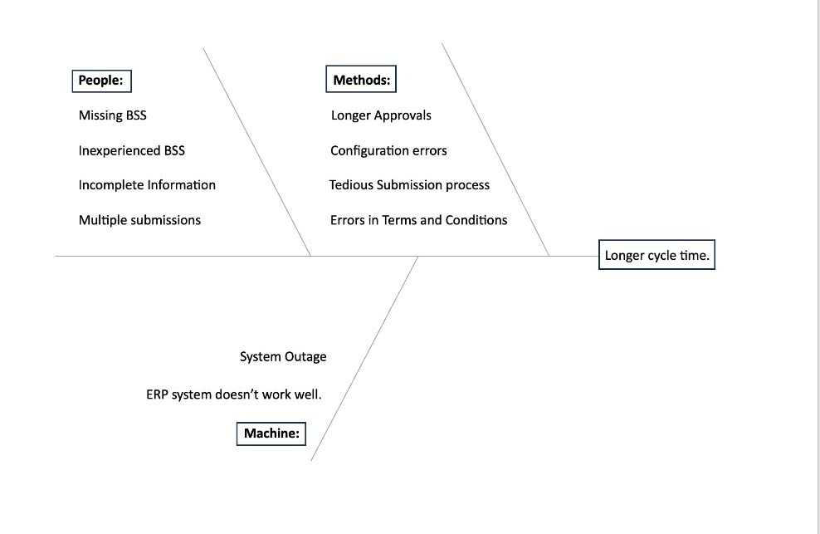

The major issues that Jeff needs to focus on are the ones that are related to BSS agents, missing information, Longer approval times which are a big factor in the longer cycle time.

**10. Recommendations:**

1. Implement a clear and efficient system for identifying and assigning BSS to requests
2. Close to 80% of the issues from the seller feedback include difficult to identify BSS agents, incorrect configuration, proposal takes too long, BSS lacks domain knowledge, and BSS inexperienced. These issues seem to be related in that the BSS agent is not able to configure the bid due to its complexity and has to pass it on to another more experienced BSS. Agents with specific roles. Additionally, we can provide comprehensive training programs for Bid Support Specialists (BSS) to enhance their domain knowledge and skills. Cross-train team members to handle responsibilities when key individuals are unavailable
3. BSS Seller Feedback also has a similar outlook with 80% of the feedback relating to Error in address provided, incomplete information, missing configuration details, missing customer address, missing seller information. All of these issues could be solved with the introduction of a form that had required fields that the seller must complete before submitting the request to a BSS. Additionally, there would need to be a verifiable address in the address field.
4. Conduct a thorough review of the ERP system to identify and rectify any inefficiencies.
5. Implement stringent quality control measures to reduce errors in configuration and incomplete requirements.
6. Streamline the proposal creation process by eliminating unnecessary steps and approvals to avoid lengthy proposal creations and long response rate.
7. Review the pricing strategy and competitiveness regularly. Explore ways to make the pricing process more efficient and responsive to market conditions.
8. Develop a comprehensive information collection process. Use automated tools to prompt users for missing details, reducing incomplete submissions.
9. Simplify the pricing approval process and implement clear guidelines. Ensure that pricing approvals align with the overall business strategy.

**11. Control Plan:**

The recommendations that are made can be controlled with consistent assessment of the BSS. These assessments should occur periodically and should allow BSS agents the chance to move up in the company. Additionally, pricing lists should be updated quarterly with market data analysis and predictive analysis.

Additional Questions:

1. New cycle times could be predicted through trials of implementing these recommendations. With 3 months of data as the changes are rolled out, we could confirm if there was a change in average total cycle time for bid proposals. Additionally, we should monitor specific timestamps to see whether or not the changes are truly impacting the intended targets in the process.

| Average cycle time | STS1 | ZQT2 | ZQT3 | ZQT4 | ZQT5 | ZQT6 | ZQT7 | ZQT8 | STSX | Total cycle time |
| --- | --- | --- | --- | --- | --- | --- | --- | --- | --- | --- |
| Old | 1.9 | 2 | 3.1 | 3.6 | 2 | 7.4 | 3.1 | 6.5 | 2 | 31.6 |
| Expected | 1.9 | 2 | 0 | 1 | 2 | 7.4 | 3.1 | 1 | 2 | 20.4 |

1. Jeff could use this text and run it through natural language processing models that gauge sentiment. They could determine whether the sentiment was negative or positive, quantify that sentiment, and track if the sentiment was changing if new data points came in and an effort was made to foster a closer team relationship.

Text classification could also be used for sentiment analysis. Key words would be pulled from each of the feedback text statements and be used to classify the sentiment into varying categories.